Withdrawal from the Contract Form
(Please complete and return this form only if you wish to withdraw from the contract)
To:
Seller: | Orodian s. r. o.
Seller’s address: | M. R. Štefánika 1068/6, 97251 Handlová, SR
Seller’s e-shop: | www.orodian.com
Seller’s e-mail: | info@orodian.com

I hereby notify that I am withdrawing from the contract for the following goods:

Order number: Order date / Date of delivery (receipt):
Optional, but completing this will speed up the processing
Consumer’s full name:

Consumer’s address:

Consumer’s e-mail:
Optional, but completing this will speed up the processing

I request the refund to be made to the following bank account number:
If not completed, the refund will be made using the same payment method you originally used.
Signature: Date:
(only if submitted in printed form)

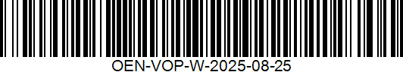
Instruction: You have the right to withdraw from the contract without giving any reason within 14 days from the date of receipt of the goods / the conclusion of a contract for the provision of services / the conclusion of a contract for the supply of digital content not supplied on a tangible medium. Please send the completed form to us by post, by e-mail, or deliver it in person to the above-mentioned address. Upon withdrawal from the contract, we will refund all payments you have made in connection with the conclusion of the contract, in particular the purchase price including the cost of delivery of the goods to you. This does not apply to any additional costs if you chose a delivery method other than the least expensive standard delivery method we offer. Payments will be refunded without undue delay and at the latest within 14 days from the day we receive your notice of withdrawal from this contract. The refund will be made using the same payment method you used for your payment, or to the bank account number you have provided in this form (according to your choice).

